Project Information DAAssignment-3
Team ID: LTVIP2026TMIDS37333
Team Size: 5
Team Leader: Buela Sindhu Thirumalasetty
Team member: Amaraadi Aswini
Team member: Rayudu Surya Sri
Team member: Kontham Harita Ganilakshmi
Team member: Ganja Aparna

ID: 226K1A4248
INSTITUTION: Ideal Institute of Technology
Project Title: Measuring the Pulse of Prosperity: An Index of Economic Freedom Analysis

Dataset Link: https://drive.google.com/file/d/1UmrCVmQFQYorNUTw414G3xot6rm46BwR/view
¡]Visualization Screenshots

1. KPI-Focused Interface
Shows key metrics—Total Sales, Gross Income, Quantity—with trend indicators, gauges, and symbol charts. Great for a high-level snapshot of branch-wise performance.
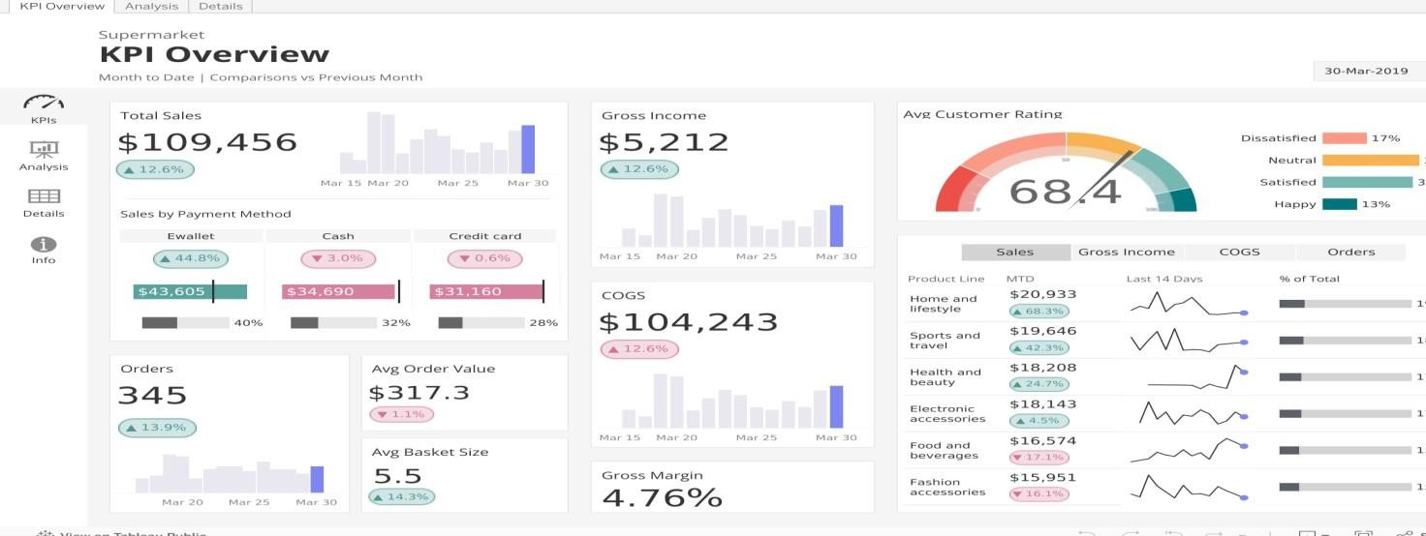

2. Multi-Component Retail Dashboard
Combines area charts, bar charts, and filterable lists in a clean layout. Offers dynamic filtering by branch, category, or time period.

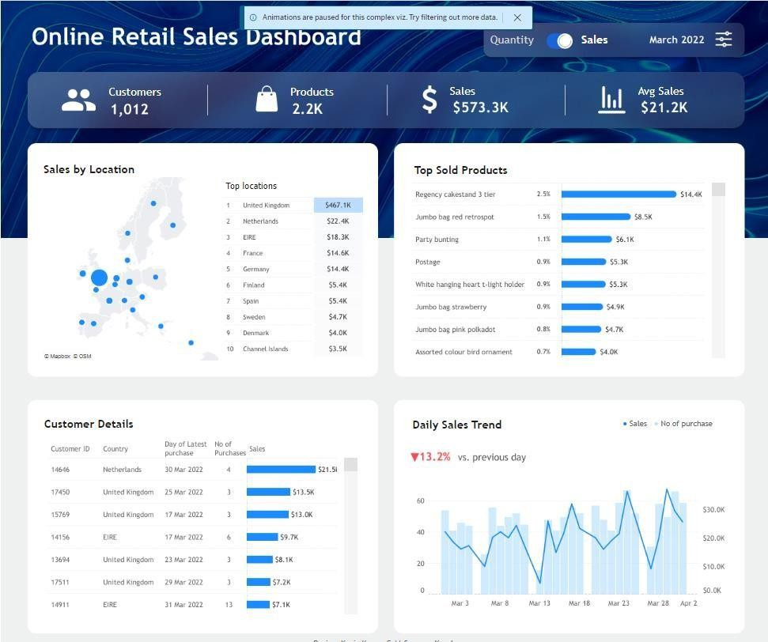

3. Time-Based Sales & Payments View
Includes monthly timelines with stacked bars and side panels for payment methods or product lines—ideal for trend and distribution analysis.
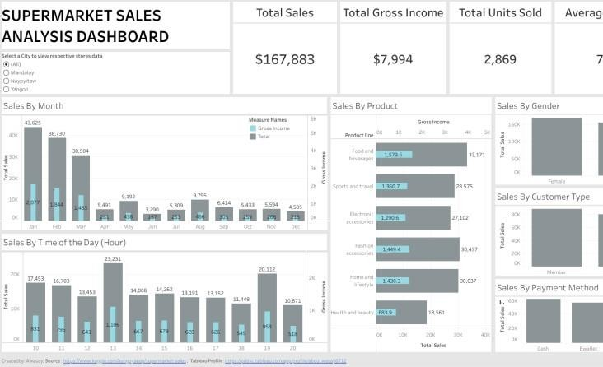

4. Dark-Themed Executive Dashboard
Features slick aesthetics with bar trends, KPIs, and product-level insights—perfect for management reporting.
